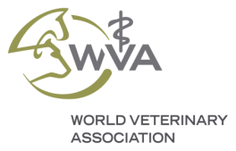
WORLD VETERINARY ASSOCIATION
ANIMAL WELFARE AWARDS 2021
SUPPORTED BY CEVA SANTE ANIMALE
APPLICATION FORM FOR VETERINARY TECHNICIAN/NURSE
NOMINATION FORM FOR VETERINARIANS

Nominations must be received no later than 1st June 2021, 1 pm CET to wva_assistant@worldvet.org

Applications must be sent in one document in PDF format and must be supported by all the requested documentation (see below list).

Information about the Nominee

- Last and first name of the nominee:

- Name of the veterinary activity (clinic, farm, laboratory, project etc.):

- Nominee professional position:

- Business address:

- Email:

- Telephone:

Information about the Nominator (self-nominations are welcome)

- Full name of the nominator:

- Nominator affiliation:

- Business address:

- Email:

- Telephone:

Signature: Date:

Nomination submission: nominations shall consist of the following:

- Complete nomination form.

- Supporting letter from one of the Constituent Members of the WVA (list of WVA members).

- Supporting letter from the nominator who is familiar with the nominee’s contributions in the Animal Welfare field giving a motivation for its nomination.

- Motivation letter by the nominee describing his/her contributions in the Animal Welfare field.

- Curriculum Vitae of the nominee.

- Any material to support the candidate (scientific articles, news items, videos, involvement in Animal Welfare projects, other recognitions etc.).

Ceva Santé Animale and the World Veterinary Association encourage qualified technicians/nurses to submit their applications and wish success to all the nominees.

