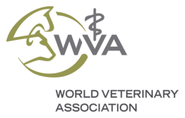
WORLD VETERINARY ASSOCIATION
ANIMAL WELFARE AWARDS 2021
SUPPORTED BY CEVA SANTE ANIMALE
APPLICATION FORM FOR VETERINARIANS

NOMINATION FORM FOR VETERINARIANS

Nominations must be received no later than 1st June 2021, 1 pm CET to wva_assistant@worldvet.org

Applications must be sent in one document in PDF format and must be supported by all the requested documentation (see below list).

Information about the Nominee

- Last and first name of the nominee:

- Veterinary title (DVM, MVSC, BVSC etc.):

- Business address:

- Email:

- Telephone:

Information about the Nominator (self-nominations are welcome)

- Last and first name of the nominator:

- Nominator affiliation:

- Business address:

- Email:

- Telephone:

Signature: Date:

Nomination submission: Nominations shall consist of the following documents:

- Complete nomination form.

- Supporting letter from one of the WVA Constituent Member Associations (list of WVA members).

- Supporting letter from the nominator who is familiar with the nominee’s contributions in the Animal Welfare field giving a motivation for its nomination.

- Motivation letter by the nominee describing his/her contributions in the Animal Welfare field.

- Professional CV of the nominee.

- Any material to support the candidate (scientific articles, news items, videos, involvement in Animal Welfare projects, other recognitions etc.).

Ceva Santé Animale and the World Veterinary Association encourage qualified veterinarians to submit their applications and wish success to all the nominees.

